

**HELP MATRICULATION CENTRE**

**MAY SEMESTER 2022**

**PROGRAMMING TEST**

(DOCUMENTATION)

**Subject Code :** FDPRG001

**Subject Name :** INTRODUCTION TO PROGRAMMING

**Student Name :** CHEAH WAN XIN

**Student ID :** B2101241

**Table of contents**

|  |  |  |
| --- | --- | --- |
| Contents | | Page |
| 1. Design of the program | 1. Flowchart (Overview) | 3 |
| 1. Flowchart (Part by part) | 4 – 12 |
| 1. Pseudocode | 13 - 33 |
| 1. Explanation of code and output | | 34 - 61 |

# Design of the program

# Flowchart (Overview)

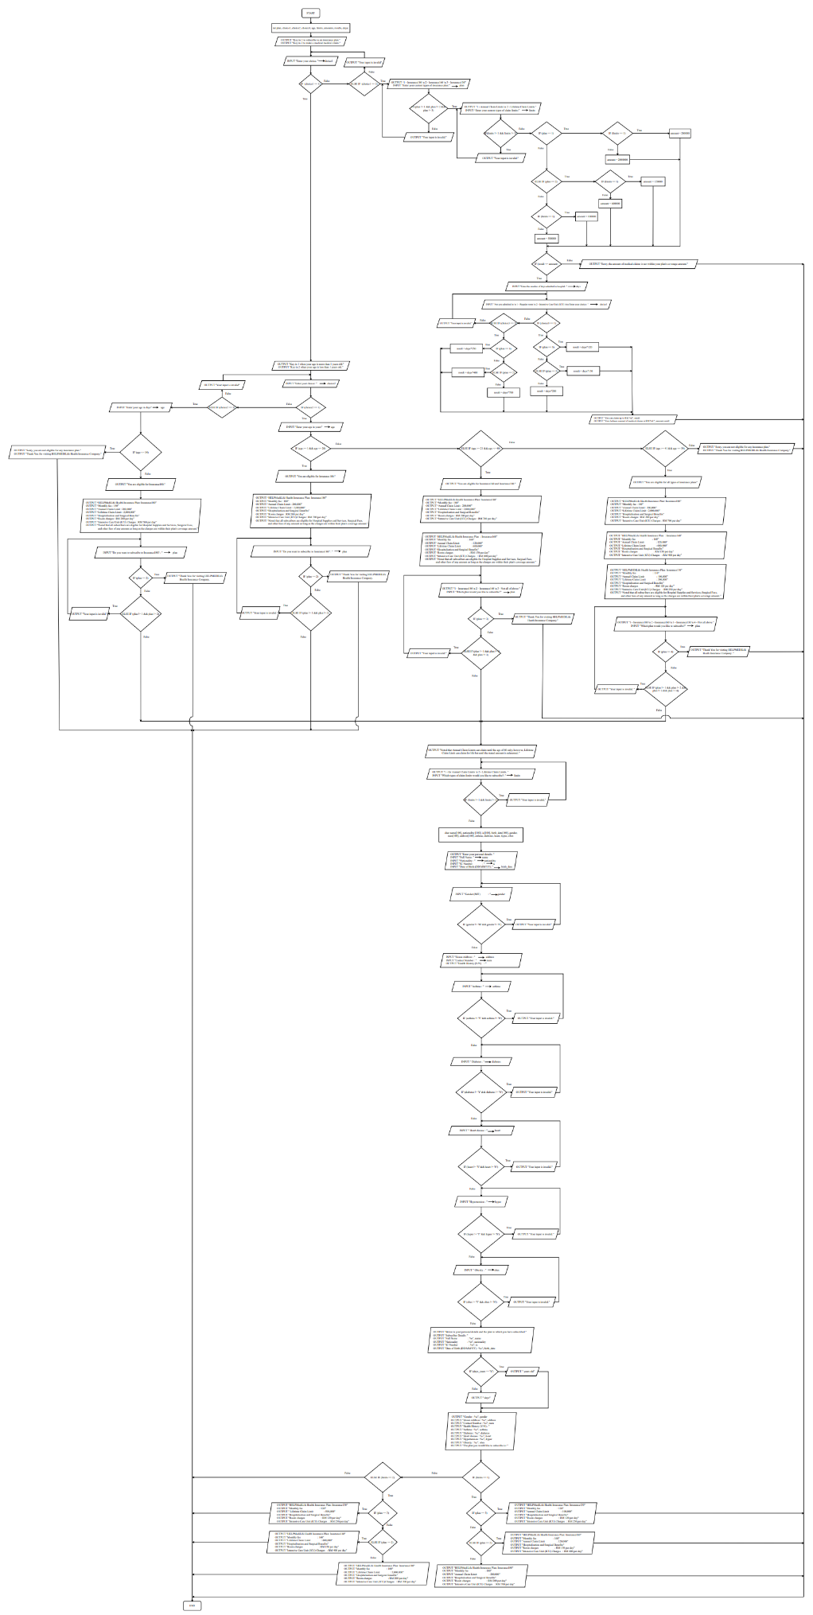

Part 2

Part 1

Part 3

Part 5

Part 8

Part 9

Part 7

Part 4

Part 6

# Flowchart (Part by part)

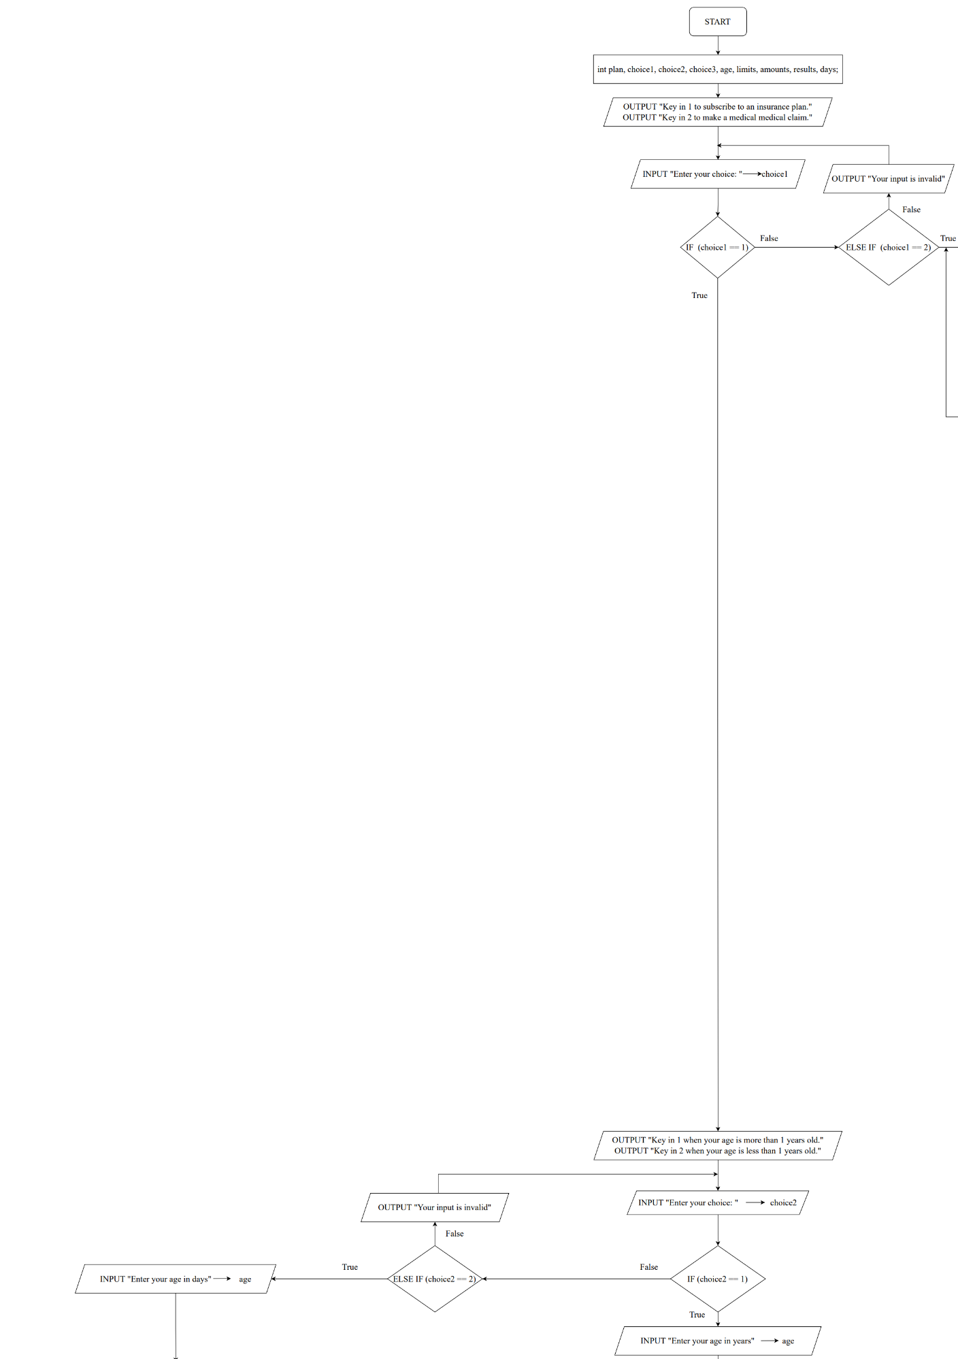Part 1

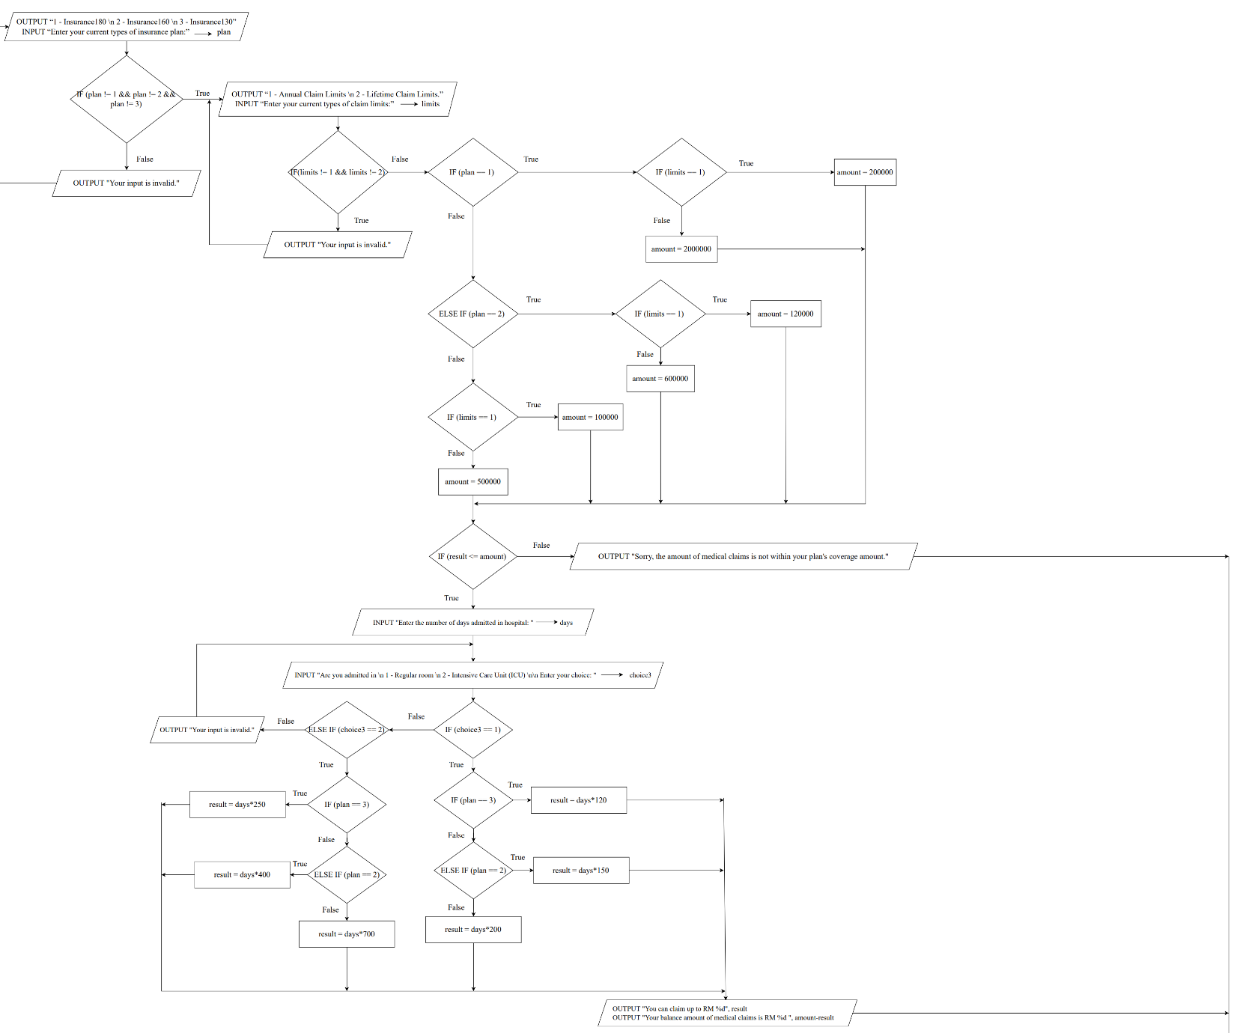Part 2

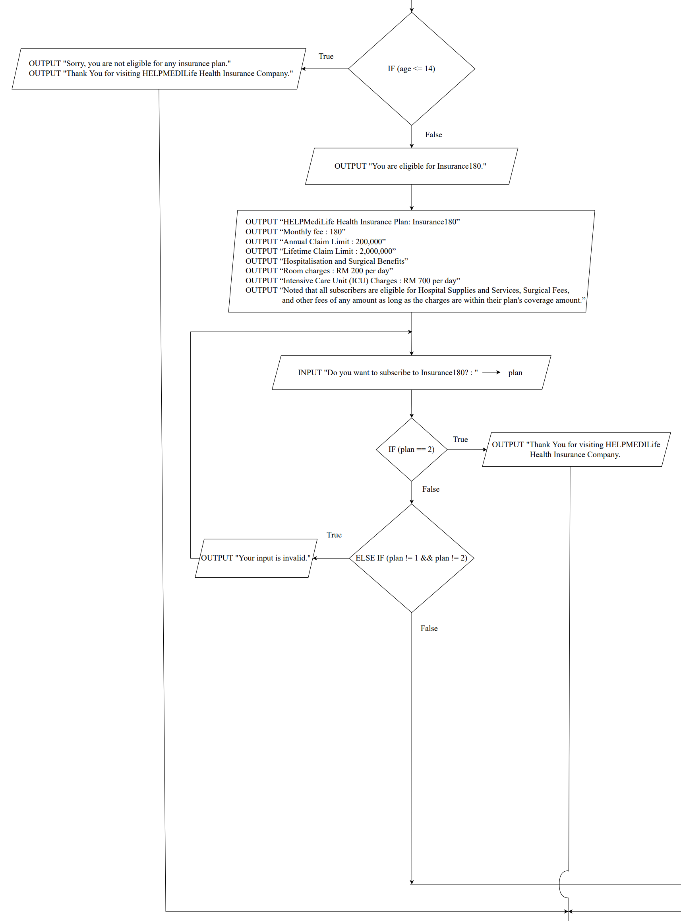Part 3

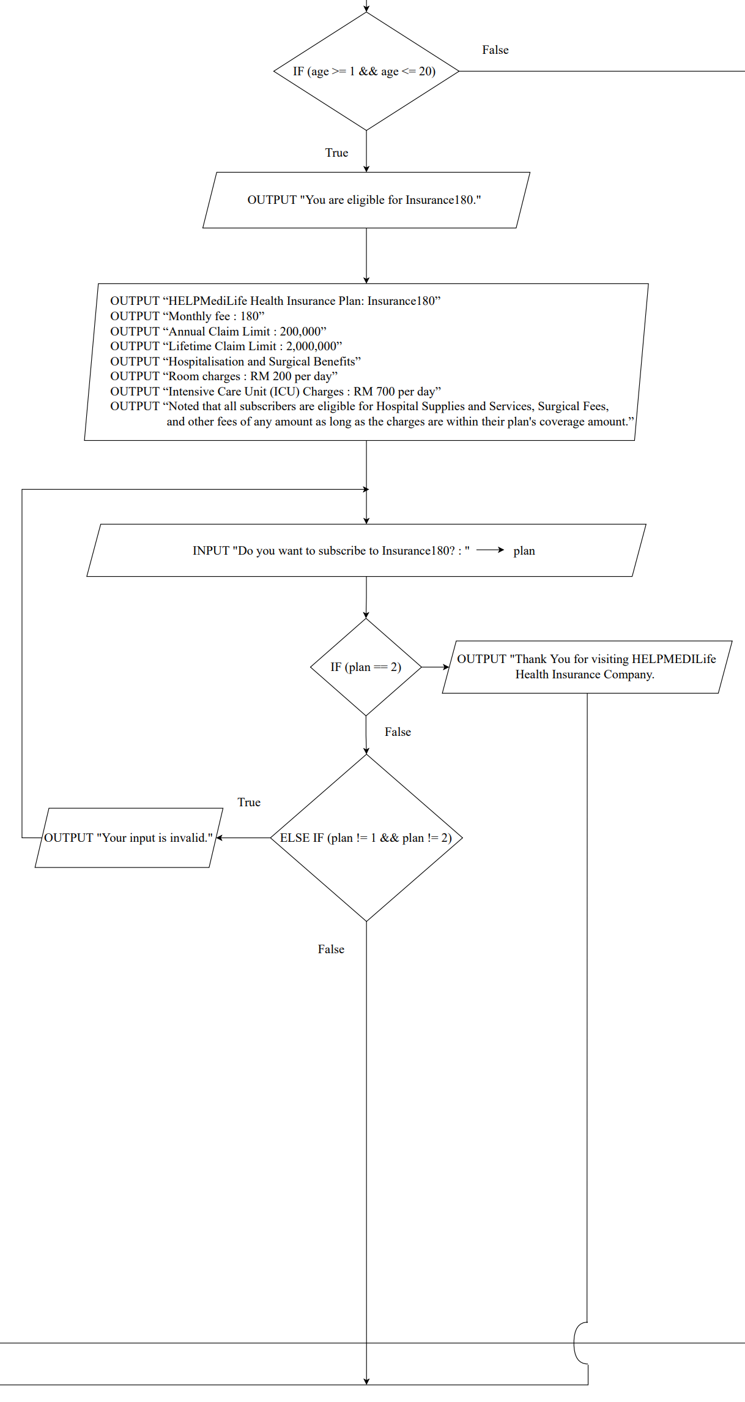Part 4

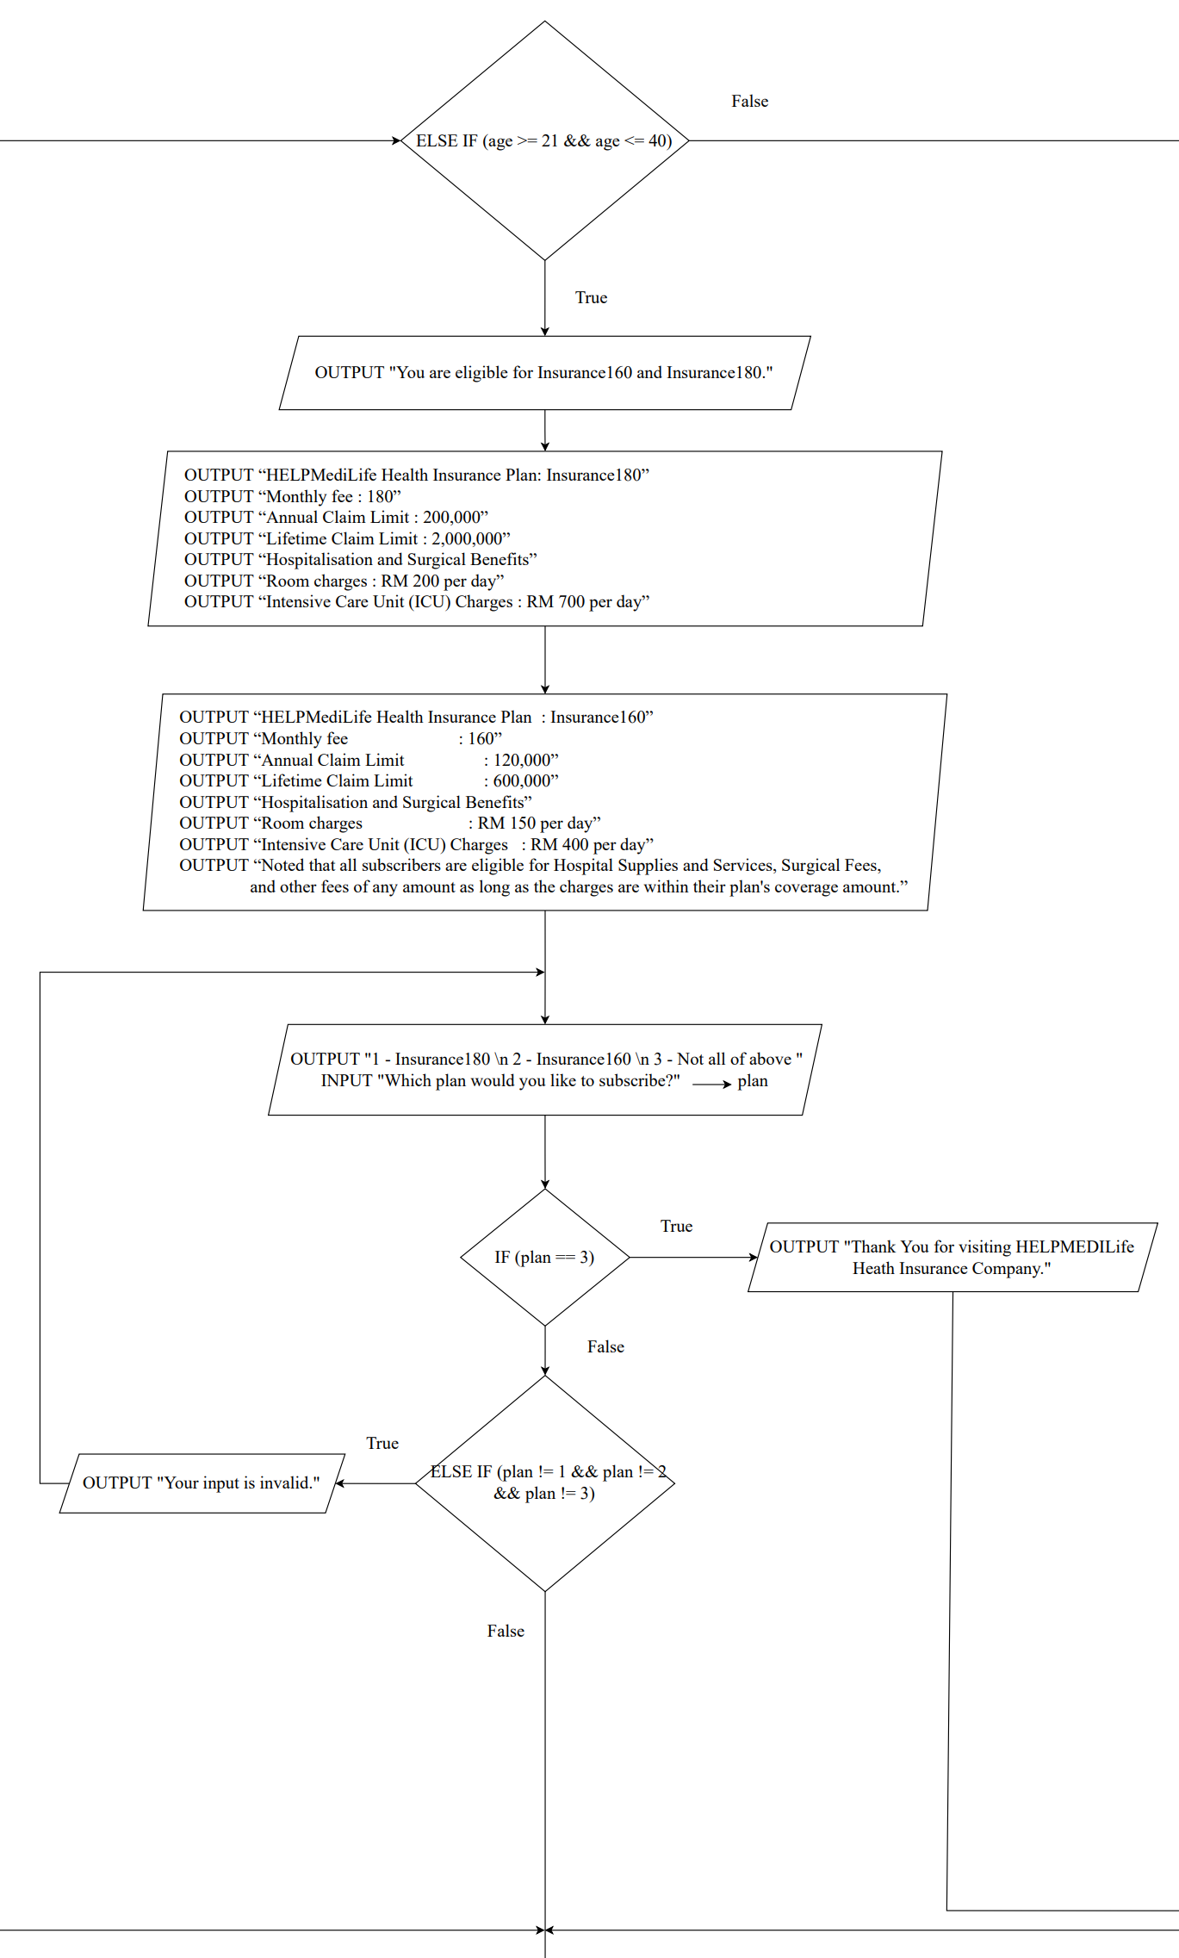Part 5

Part 6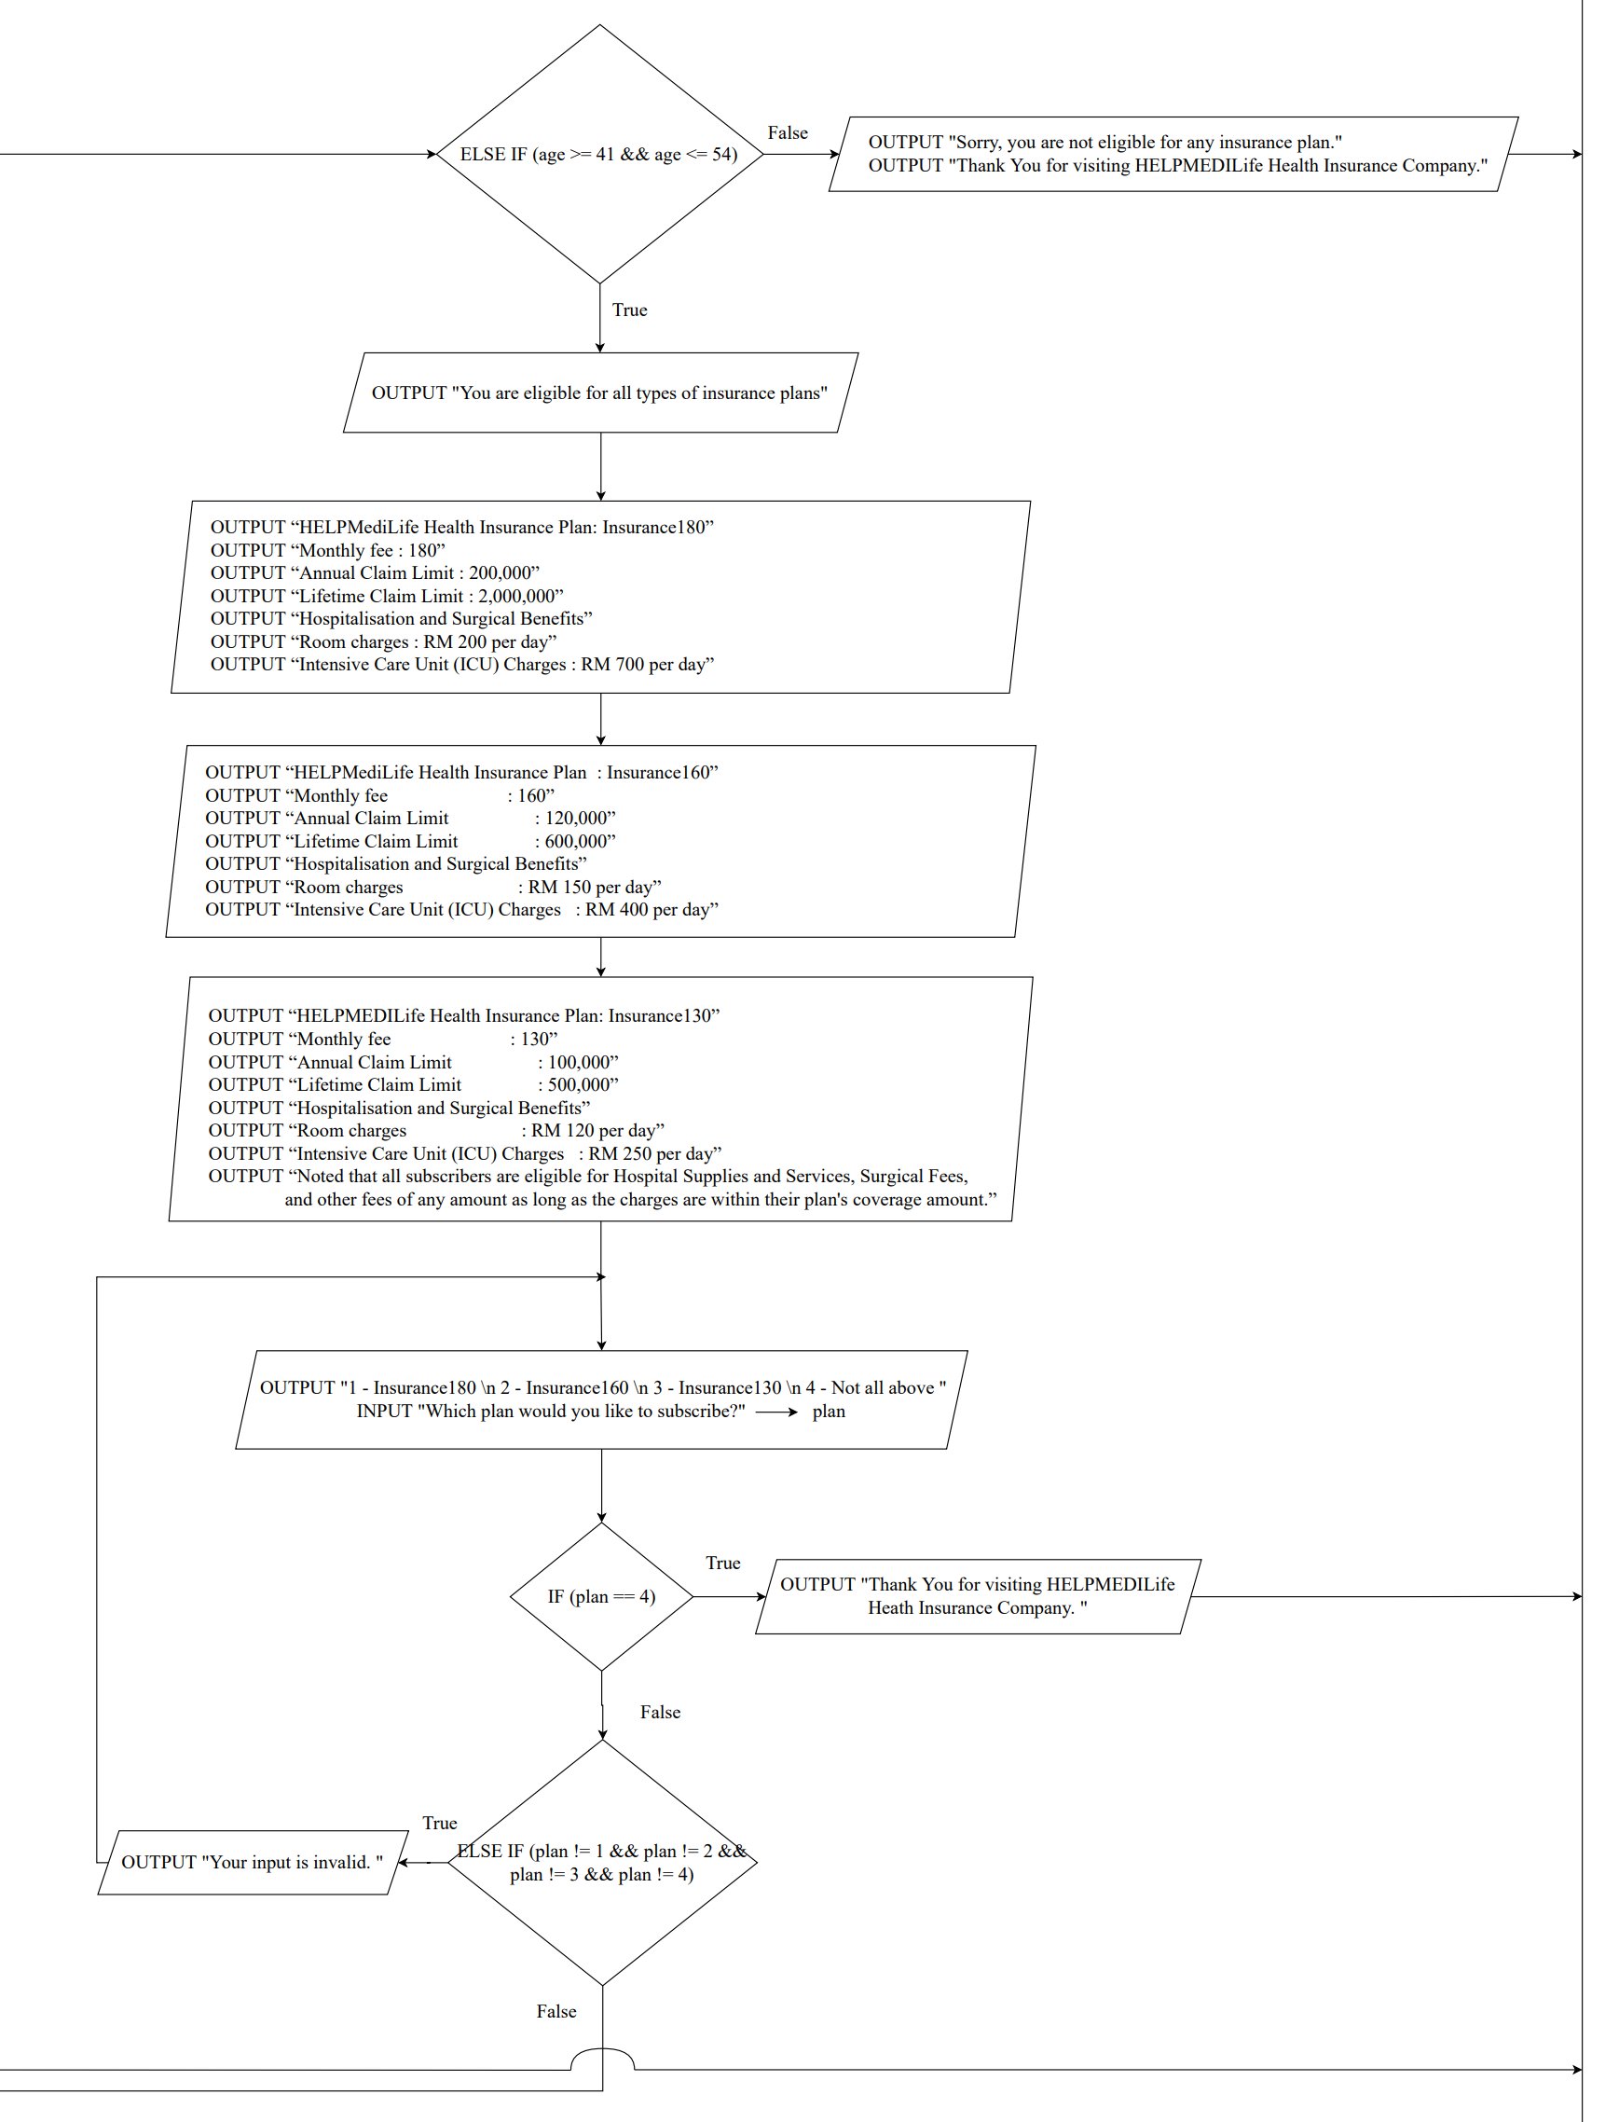

Part 7

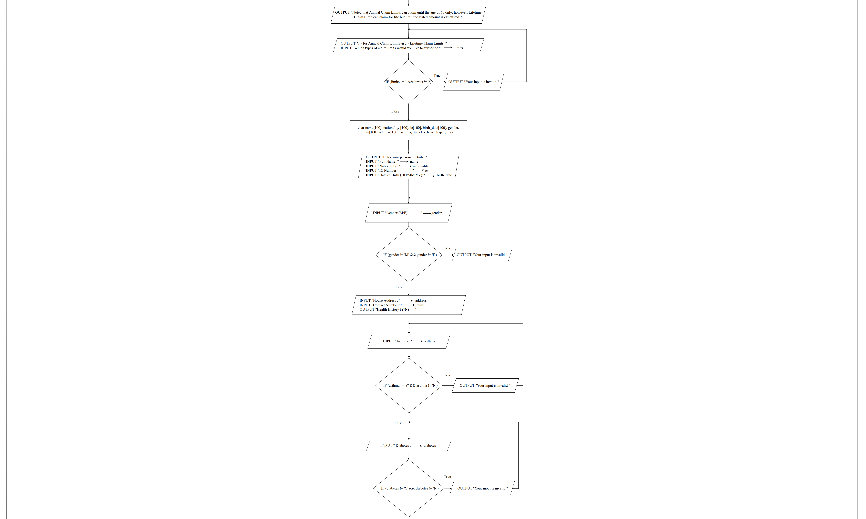

Part 8

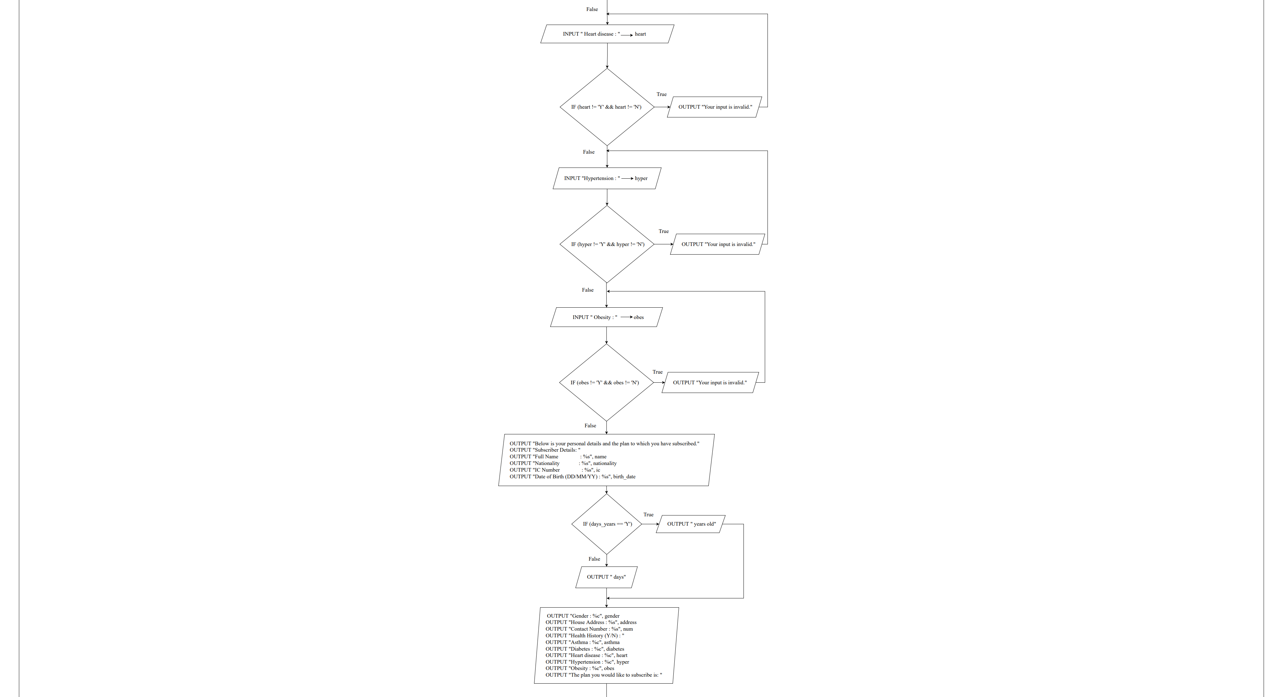

Part 9

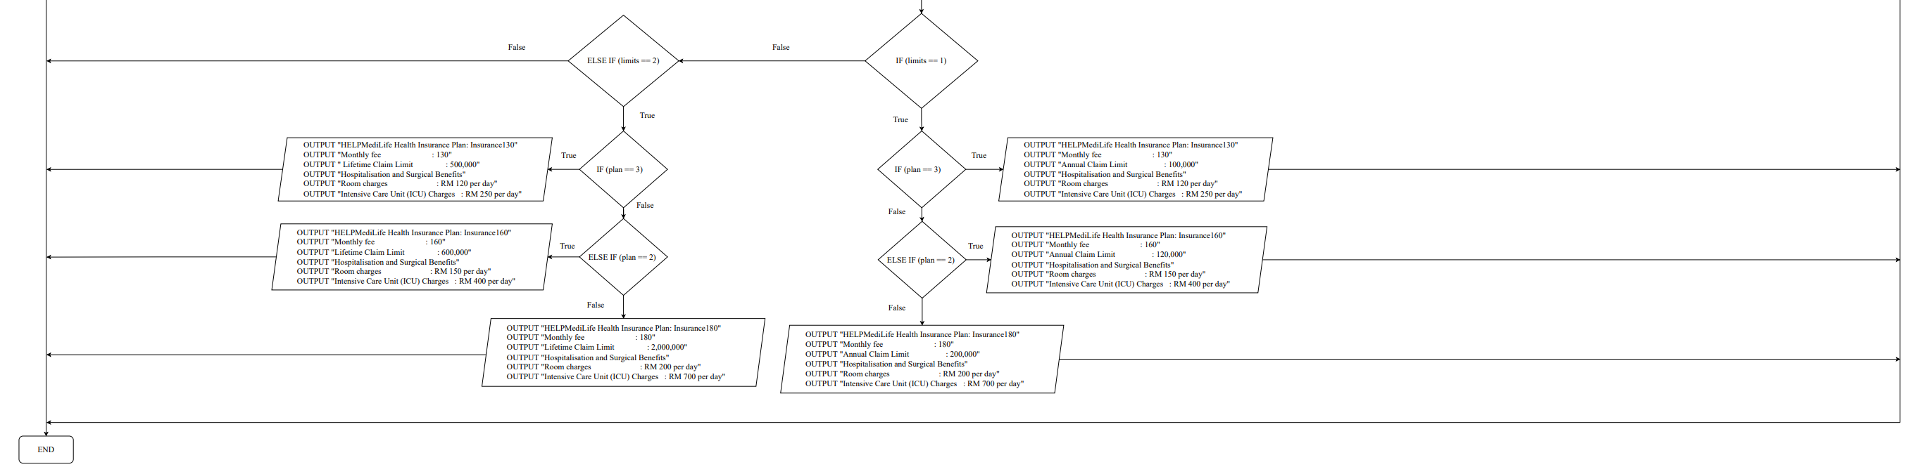

# Pseudocode

START

INTEGER plan, choice1, choice2, age, limits, amount, results, days

OUTPUT “Key in 1 to subscribe to an insurance plan.”

OUTPUT “Key in 2 to make a medical claim.”

WHILE choice1 != 1 && choice1 != 2

OUTPUT “Enter your choice: ”

INPUT choice1

IF choice1 == 1

OUTPUT “Key in 1 when your age is more than 1 years old.”

OUTPUT “Key in 2 when your age is less than 1 years old.”

WHILE choice2 != 1 && choice2 != 2

OUTPUT “Enter your choice: ”

INPUT choice2

IF choice2 ==1

OUTPUT “Enter your age in years: ”

INPUT age

IF age >= 1 && age <= 20

OUTPUT “You are eligible for Insurance180.”

OUTPUT “HELPMediLife Health Insurance Plan: Insurance180”

OUTPUT “Monthly fee : 180”

OUTPUT “Annual Claim Limit : 200,000”

OUTPUT “Lifetime Claim Limit : 2,000,000”

OUTPUT “Hospitalisation and Surgical Benefits”

OUTPUT “Room charges : RM 200 per day”

OUTPUT “Intensive Care Unit (ICU) Charges : RM 700 per day”

OUTPUT “Noted that all subscribers are eligible for Hospital Supplies and Services, Surgical Fees, and

other fees of any amount as long as the charges are within their plan's coverage amount.”

WHILE plan != 1 && plan != 2

OUTPUT “1 - Yes \n 2 - No”

OUTPUT “Do you want to subscribe to Insurance180? : ”

INPUT plan

IF plan == 2

OUTPUT “Thank You for visiting HELPMEDILife Health Insurance Company.”

TERMINATE

ELSE IF plan != 1 && plan != 2

OUTPUT “Your input is invalid.”

ELSE IF age >= 21 && age <= 40

OUTPUT “You are eligible for Insurance160 and Insurance180.”

OUTPUT “HELPMediLife Health Insurance Plan: Insurance180”

OUTPUT “Monthly fee : 180”

OUTPUT “Annual Claim Limit : 200,000”

OUTPUT “Lifetime Claim Limit : 2,000,000”

OUTPUT “Hospitalisation and Surgical Benefits”

OUTPUT “Room charges : RM 200 per day”

OUTPUT “Intensive Care Unit (ICU) Charges : RM 700 per day”

OUTPUT “HELPMediLife Health Insurance Plan : Insurance160”

OUTPUT “Monthly fee : 160”

OUTPUT “Annual Claim Limit : 120,000”

OUTPUT “Lifetime Claim Limit : 600,000”

OUTPUT “Hospitalisation and Surgical Benefits”

OUTPUT “Room charges : RM 150 per day”

OUTPUT “Intensive Care Unit (ICU) Charges : RM 400 per day”

OUTPUT “Noted that all subscribers are eligible for Hospital Supplies and Services, Surgical Fees, and

other fees of any amount as long as the charges are within their plan's coverage amount.”

WHILE plan != 1 && plan != 2 && plan != 3

OUTPUT “1 - Insurance180 \n 2 - Insurance160 \n 3 - Not all of above”

OUTPUT “Which plan would you like to subscribe?: ”

INPUT plan

IF plan == 3

OUTPUT “Thank You for visiting HELPMEDILife Health Insurance Company.”

TERMINATE

ELSE IF plan != 1 && plan != 2 && plan != 3

OUTPUT “Your input is invalid.”

ELSE IF age >= 41 && age <= 54

OUTPUT “You are eligible for all type of insurance plans.”

OUTPUT “HELPMediLife Health Insurance Plan: Insurance180”

OUTPUT “Monthly fee : 180”

OUTPUT “Annual Claim Limit : 200,000”

OUTPUT “Lifetime Claim Limit : 2,000,000”

OUTPUT “Hospitalisation and Surgical Benefits”

OUTPUT “Room charges : RM 200 per day”

OUTPUT “Intensive Care Unit (ICU) Charges : RM 700 per day”

OUTPUT “HELPMediLife Health Insurance Plan : Insurance160”

OUTPUT “Monthly fee : 160”

OUTPUT “Annual Claim Limit : 120,000”

OUTPUT “Lifetime Claim Limit : 600,000”

OUTPUT “Hospitalisation and Surgical Benefits”

OUTPUT “Room charges : RM 150 per day”

OUTPUT “Intensive Care Unit (ICU) Charges : RM 400 per day”

OUTPUT “HELPMEDILife Health Insurance Plan: Insurance130”

OUTPUT “Monthly fee : 130”

OUTPUT “Annual Claim Limit : 100,000”

OUTPUT “Lifetime Claim Limit : 500,000”

OUTPUT “Hospitalisation and Surgical Benefits”

OUTPUT “Room charges : RM 120 per day”

OUTPUT “Intensive Care Unit (ICU) Charges : RM 250 per day”

OUTPUT “Noted that all subscribers are eligible for Hospital Supplies and Services, Surgical Fees, and

other fees of any amount as long as the charges are within their plan's coverage amount.”

WHILE plan != 1 && plan != 2 && plan != 3 && plan != 4

OUTPUT “1 - Insurance180 \n 2 - Insurance160 \n 3 - Insurance130 \n 4 - Not all of above”

OUTPUT “Which plan would you like to subscribe?: ”

INPUT plan

IF plan == 4

OUTPUT “Thank You for visiting HELPMEDILife Health Insurance Company.”

TERMINATE

ELSE IF plan != 1 && plan != 2 && plan != 3 && plan != 4

OUTPUT “Your input is invalid.”

ELSE

OUTPUT “Sorry, you are not eligible for any insurance plan.”

OUTPUT “Thank You for visiting HELPMEDILife Health Insurance Company.”

TERMINATE

ELSE IF choice2 == 2

OUTPUT “Enter your age in days: ”

INPUT age

IF age <= 14

OUTPUT “Sorry, you are not eligible for any insurance plan.”

OUTPUT “Thank You for visiting HELPMEDILife Health Insurance Company.”

TERMINATE

ELSE IF age <= 364 && age >= 15

OUTPUT “You are eligible for Insurance180.”

OUTPUT “HELPMediLife Health Insurance Plan: Insurance180”

OUTPUT “Monthly fee : 180”

OUTPUT “Annual Claim Limit : 200,000”

OUTPUT “Lifetime Claim Limit : 2,000,000”

OUTPUT “Hospitalisation and Surgical Benefits”

OUTPUT “Room charges : RM 200 per day”

OUTPUT “Intensive Care Unit (ICU) Charges : RM 700 per day”

OUTPUT “Noted that all subscribers are eligible for Hospital Supplies and Services, Surgical Fees, and

other fees of any amount as long as the charges are within their plan's coverage amount.”

WHILE plan != 1 && plan != 2

OUTPUT “1 - Yes \n 2 - No”

OUTPUT “Do you want to subscribe to Insurance180? : ”

INPUT plan

IF plan == 2

OUTPUT “Thank You for visiting HELPMEDILife Health Insurance Company.”

TERMINATE

ELSE IF plan != 1 && plan != 2

OUTPUT “Your input is invalid.”

OUTPUT “*** Noted that Annual Claim Limits can claim until the age of 60 only; however, Lifetime Claim Limit can claim for

life but until the stated amount is exhausted.***”

WHILE limits != 1 && limits != 2

OUTPUT “1 - Annual Claim Limits \n 2 - Lifetime Claim Limits.”

OUTPUT “Which types of claim limits would you like to subscribe?:”

INPUT limits

IF limits != 1 && limits != 2

OUTPUT “Your input is invalid.”

CHARACTER name [100], nationality [100], ic[100], birth_date[100], gender, num[100], address[100], asthma, diabetes, heart, hyper, obes

OUTPUT “Enter your personal details: ”

OUTPUT “Full Name : ”

INPUT name

OUTPUT “Nationality : ”

INPUT nationality

OUTPUT “IC Number : ”

INPUT ic

OUTPUT “Date of Birth (DD/MM/YY): ”

INPUT birth_date

WHILE gender != 'M' && gender != 'F'

OUTPUT “Gender (M/F) : ”

INPUT gender

IF gender != 'M' && gender != 'F'

OUTPUT “Your input is invalid.”

OUTPUT “House Address : ”

INPUT address

OUTPUT “Contact Number : ”

INPUT num

OUTPUT “Health History (Y/N) : ”

WHILE asthma != 'Y' && asthma != 'N'

OUTPUT “Asthma : ”

INPUT asthma

IF asthma != 'Y' && asthma != 'N'

OUTPUT “Your input is invalid.”

WHILE diabetes != 'Y' && diabetes != 'N'

OUTPUT “Diabetes : ”

INPUT diabetes

IF diabetes != 'Y' && diabetes != 'N'

OUTPUT “Your input is invalid.”

WHILE heart != 'Y' && heart != 'N’

OUTPUT “Heart disease : ”

INPUT heart

IF heart != 'Y' && heart != 'N’

OUTPUT “Your input is invalid.”

WHILE hyper != 'Y' && hyper != 'N'

OUTPUT “Hypertension : ”

INPUT hyper

IF hyper != 'Y' && hyper != 'N'

OUTPUT “Your input is invalid.”

WHILE obes != 'Y' && obes != 'N'

OUTPUT “Obesity : ”

INPUT obes

IF obes != 'Y' && obes != 'N'

OUTPUT “Your input is invalid.”

OUTPUT “Below is your personal details and the plan to which you have subscribed.”

OUTPUT “Subscriber Details: ”

OUTPUT “Full Name : %s”, name

OUTPUT “Nationality : %s”, nationality

OUTPUT “IC Number : %s”, ic

OUTPUT “Date of Birth (DD/MM/YY) : %s”, birth_date

OUTPUT “Age : %d”, age

IF choice2 == 1

OUTPUT “ years old”

ELSE

OUTPUT “ days”

OUTPUT “Gender : %c”, gender

OUTPUT “House Address : %s”, address

OUTPUT “Contact Number : %s”, num

OUTPUT “Health History (Y/N) : ”

OUTPUT “Asthma : %c”, asthma

OUTPUT “Diabetes : %c”, diabetes

OUTPUT “Heart disease : %c”, heart

OUTPUT “Hypertension : %c”, hyper

OUTPUT “Obesity : %c ”, obes

OUTPUT “The plan you would like to subscribe is: ”

IF limits == 1

IF plan == 3

OUTPUT “HELPMEDILife Health Insurance Plan: Insurance130”

OUTPUT “Monthly fee : 130”

OUTPUT “Annual Claim Limit : 100,000”

OUTPUT “Hospitalisation and Surgical Benefits”

OUTPUT “Room charges : RM 120 per day”

OUTPUT “Intensive Care Unit (ICU) Charges : RM 250 per day”

ELSE IF plan == 2 OUTPUT “HELPMediLife Health Insurance Plan : Insurance160”

OUTPUT “Monthly fee : 160”

OUTPUT “Annual Claim Limit : 120,000”

OUTPUT “Hospitalisation and Surgical Benefits”

OUTPUT “Room charges : RM 150 per day”

OUTPUT “Intensive Care Unit (ICU) Charges : RM 400 per day”

ELSE

OUTPUT “HELPMediLife Health Insurance Plan: Insurance180”

OUTPUT “Monthly fee : 180”

OUTPUT “Annual Claim Limit : 200,000”

OUTPUT “Hospitalisation and Surgical Benefits”

OUTPUT “Room charges : RM 200 per day”

OUTPUT “Intensive Care Unit (ICU) Charges : RM 700 per day”

ELSE IF limits == 2

IF plan == 3

OUTPUT “HELPMediLife Health Insurance Plan: Insurance180”

OUTPUT “Monthly fee : 180”

OUTPUT “Lifetime Claim Limit : 2,000,000”

OUTPUT “Hospitalisation and Surgical Benefits”

OUTPUT “Room charges : RM 200 per day”

OUTPUT “Intensive Care Unit (ICU) Charges : RM 700 per day”

ELSE IF plan == 2

OUTPUT “HELPMediLife Health Insurance Plan : Insurance160”

OUTPUT “Monthly fee : 160”

OUTPUT “Lifetime Claim Limit : 600,000”

OUTPUT “Hospitalisation and Surgical Benefits”

OUTPUT “Room charges : RM 150 per day”

OUTPUT “Intensive Care Unit (ICU) Charges : RM 400 per day”

ELSE

OUTPUT “HELPMEDILife Health Insurance Plan: Insurance130”

OUTPUT “Monthly fee : 130”

OUTPUT “Lifetime Claim Limit : 500,000”

OUTPUT “Hospitalisation and Surgical Benefits”

OUTPUT “Room charges : RM 120 per day”

OUTPUT “Intensive Care Unit (ICU) Charges : RM 250 per day”

ELSE IF choice1 == 2

WHILE plan != 1 && plan != 2 && plan != 3

OUTPUT “1 - Insurance180 \n 2 - Insurance160 \n 3 - Insurance130”

OUTPUT “Enter your current types of insurance plan:”

INPUT plan

IF plan != 1 && plan != 2 && plan != 3

OUTPUT “Your input is invalid.”

WHILE limits != 1 && limits != 2

OUTPUT “1 - Annual Claim Limits \n 2 - Lifetime Claim Limits.”

OUTPUT “Enter your current types of claim limits:”

INPUT “limits”

IF limits != 1 && limits != 2

OUTPUT “Your input is invalid.”

IF plan == 1

IF limits == 1

amount = 200000

OUTPUT “Enter the number of days admitted in hospital: ”

INPUT days

WHILE choice3 != 1 && choice3 != 2

OUTPUT “Are you admitted in \n 1 - Regular room \n 2 - Intensive Care Unit (ICU)”

OUTPUT “Enter your choice:”

INPUT choice3

IF choice 3 == 1

IF plan == 3

COMPUTE result = days*120

ELSE IF plan == 2

COMPUTE result = days*150

ELSE

COMPUTE result = days*200

ELSE IF choice3 == 2

IF plan == 3

COMPUTE result = days*250

ELSE IF plan == 2

COMPUTE result = days*400

ELSE

COMPUTE result = days*700

ELSE

OUTPUT “Your input is invalid.”

IF amount – result > 0

OUTPUT “You can claim up to RM %d”, result

OUTPUT “Your balance amount medical claims is RM %d”, amount-result

ELSE

OUTPUT “Sorry, the amount of medical claims is not within your plan's coverage amount.”

ELSE

amount = 2000000

OUTPUT “Enter the number of days admitted in hospital: ”

INPUT days

WHILE choice3 != 1 && choice3 != 2

OUTPUT “Are you admitted in \n 1 - Regular room \n 2 - Intensive Care Unit (ICU)”

OUTPUT “Enter your choice:”

INPUT choice3

IF choice 3 == 1

IF plan == 3

COMPUTE result = days*120

ELSE IF plan == 2

COMPUTE result = days*150

ELSE

COMPUTE result = days*200

ELSE IF choice3 == 2

IF plan == 3

COMPUTE result = days*250

ELSE IF plan == 2

COMPUTE result = days*400

ELSE

COMPUTE result = days*700

ELSE

OUTPUT “Your input is invalid.”

IF amount – result > 0

OUTPUT “You can claim up to RM %d”, result

OUTPUT “Your balance amount medical claims is RM %d”, amount-result

ELSE

OUTPUT “Sorry, the amount of medical claims is not within your plan's coverage amount.”

ELSE IF plan == 2

IF limits == 1

amount = 120000

OUTPUT “Enter the number of days admitted in hospital: ”

INPUT days

WHILE choice3 != 1 && choice3 != 2

OUTPUT “Are you admitted in \n 1 - Regular room \n 2 - Intensive Care Unit (ICU)”

OUTPUT “Enter your choice:”

INPUT choice3

IF choice 3 == 1

IF plan == 3

COMPUTE result = days*120

ELSE IF plan == 2

COMPUTE result = days*150

ELSE

COMPUTE result = days*200

ELSE IF choice3 == 2

IF plan == 3

COMPUTE result = days*250

ELSE IF plan == 2

COMPUTE result = days*400

ELSE

COMPUTE result = days*700

ELSE

OUTPUT “Your input is invalid.”

IF amount – result > 0

OUTPUT “You can claim up to RM %d”, result

OUTPUT “Your balance amount medical claims is RM %d”, amount-result

ELSE

OUTPUT “Sorry, the amount of medical claims is not within your plan's coverage amount.”

ELSE

amount = 600000

OUTPUT “Enter the number of days admitted in hospital: ”

INPUT days

WHILE choice3 != 1 && choice3 != 2

OUTPUT “Are you admitted in \n 1 - Regular room \n 2 - Intensive Care Unit (ICU)”

OUTPUT “Enter your choice:”

INPUT choice3

IF choice 3 == 1

IF plan == 3

COMPUTE result = days*120

ELSE IF plan == 2

COMPUTE result = days*150

ELSE

COMPUTE result = days*200

ELSE IF choice3 == 2

IF plan == 3

COMPUTE result = days*250

ELSE IF plan == 2

COMPUTE result = days*400

ELSE

COMPUTE result = days*700

ELSE

OUTPUT “Your input is invalid.”

IF amount – result > 0

OUTPUT “You can claim up to RM %d”, result

OUTPUT “Your balance amount medical claims is RM %d”, amount-result

ELSE

OUTPUT “Sorry, the amount of medical claims is not within your plan's coverage amount.”

ELSE

IF limits == 1

amount = 100000

OUTPUT “Enter the number of days admitted in hospital: ”

INPUT days

WHILE choice3 != 1 && choice3 != 2

OUTPUT “Are you admitted in \n 1 - Regular room \n 2 - Intensive Care Unit (ICU)”

OUTPUT “Enter your choice:”

INPUT choice3

IF choice 3 == 1

IF plan == 3

COMPUTE result = days*120

ELSE IF plan == 2

COMPUTE result = days*150

ELSE

COMPUTE result = days*200

ELSE IF choice3 == 2

IF plan == 3

COMPUTE result = days*250

ELSE IF plan == 2

COMPUTE result = days*400

ELSE

COMPUTE result = days*700

ELSE

OUTPUT “Your input is invalid.”

IF amount – result > 0

OUTPUT “You can claim up to RM %d”, result

OUTPUT “Your balance amount medical claims is RM %d”, amount-result

ELSE

OUTPUT “Sorry, the amount of medical claims is not within your plan's coverage amount.”

ELSE

amount = 500000

OUTPUT “Enter the number of days admitted in hospital: ”

INPUT days

WHILE choice3 != 1 && choice3 != 2

OUTPUT “Are you admitted in \n 1 - Regular room \n 2 - Intensive Care Unit (ICU)”

OUTPUT “Enter your choice:”

INPUT choice3

IF choice 3 == 1

IF plan == 3

COMPUTE result = days*120

ELSE IF plan == 2

COMPUTE result = days*150

ELSE

COMPUTE result = days*200

ELSE IF choice3 == 2

IF plan == 3

COMPUTE result = days*250

ELSE IF plan == 2

COMPUTE result = days*400

ELSE

COMPUTE result = days*700

ELSE

OUTPUT “Your input is invalid.”

IF amount – result > 0

OUTPUT “You can claim up to RM %d”, result

OUTPUT “Your balance amount medical claims is RM %d”, amount-result

ELSE

OUTPUT “Sorry, the amount of medical claims is not within your plan's coverage amount.”

ELSE

OUTPUT “Your input is invalid.”

END

# Explanation of code and output

**Figure 1**

Before a person makes a medical claim, he or she must subscribe to one of the insurance plans based on his or her eligibility. Therefore, the program will begin by asking whether he or she wants to make a medical claim or subscribe to an insurance plan. If he or she wants to subscribe to an insurance plan, the program will ask whether he or she is more than one year old or less than one year old because only a person who is within the age range of 15 days to 54 years old is eligible to subscribe to a plan. When his or her age is more than one year old, the program will prompt for his or her age in years. On the other hand, the program will ask for his or her age in days. The code with a sample output is shown in Figure 1.

**Figure 2**

Output:

* Text

  Description automatically generatedCondition 1: He or she want to subscribe to insurance180
* Text

  Description automatically generatedCondition 2: He or she does not want to subscribe to insurance180

When a person’s age is between the range of 1 and 20 years old, the program will display the plan details and benefits of insurance180. Next, the program will ask whether he or she wants to subscribe to insurance180. If he or she wants to subscribe to insurance180, they need to input 1 for yes and input 2 for no. If he or she inputs 2, the program will terminate. If he or she inputs 1, the program will proceed to the next function. The code with a sample output is shown in Figure 2.

**Figure 3**

Output:

* Text

  Description automatically generatedCondition 1: He or she subscribe to either insurance180 or insurance160
* Text

  Description automatically generatedCondition 2: He or she does not want to subscribe to any insurance plan.

On the other hand, the program will display the plan’s details and benefits for insurance180 and insurance160 when his or her age is within the range of 21 to 40 years old. The program will then ask whether he or she wants to subscribe to insurance180, insurance160, or whether he or she does not want to subscribe to any insurance plan. When he or she subscribes to insurance180 or insurance160, the program will proceed to prompt for the types of claim limits he or she wants to subscribe to. In contrast, the program will terminate when he or she does not want to subscribe to any insurance plan. The code with a sample output is shown in Figure 3.

**Figure 4**

Output:

* Graphical user interface, text

  Description automatically generatedCondition 1: He or she subscribe to either insurance180, insurance160, or insurance130
* Text

  Description automatically generatedCondition 2: He or she does not subscribe to any insurance plan.
* Text

  Description automatically generatedHis or her age is not within the range of 1 to 54 years old

In addition, the program will display the plan’s details and benefits for insurance180, insurance160, and insurance130 when his or her age is within the range of 41 to 54 years old. The program will then ask whether he or she wants to subscribe to insurance180, insurance160, insurance130, or whether he or she does not want to subscribe to any insurance plan. When he or she subscribes to either insurance180, insurance160, or insurance130, the program will proceed to prompt for the types of claim limits he or she wants to subscribe to. In contrast, the program will terminate when he or she does not want to subscribe to any insurance plan. Also, the program will terminate when his or her age is not within the range of 1 to 54 years old. The code with a sample output is shown in Figure 4.

**Figure 5**

Output:

* Text

  Description automatically generatedCondition 1: His or her age is less than or equal to 14 days
* Text

  Description automatically generatedCondition 2: His or her age is more than or equal to 15 days
  + Text

    Description automatically generatedCondition 1: He or she does not want to subscribe to insurance180
  + A picture containing text, indoor, screenshot

    Description automatically generatedCondition 2: He or she want to subscribe to insurance180

Furthermore, the program will prompt for their age in days when his or her age is less than 1 year old. When his or her age is less than or equal to 14 days, the program will terminate. On the contrary, the program will display details and benefits for insurance180 when his or her age is more than or equal to 15 days. Next, the program will ask whether he or she wants to subscribe to insurance180. When he or she does not want to subscribe to insurance180, the program will terminate. However, the program will proceed to prompt for the types of claim limits only when he or she subscribes to insurance180. The code with a sample output is shown in Figure 5.

**Figure 6**

1. Graphical user interface, application

   Description automatically generatedPrompt for types of claim limits

Output:

1. Prompt for personal details

Output:

1. Display the subscriber’s details followed by his or her subscribed plan details and benefits.

Output:

After subscribing to an insurance plan, the program will prompt for the types of claim limits, which are either lifetime or annual claim limits, he or she would like to subscribe to. Then, the program will prompt for personal details such as name, nationality, identification card number, and health history. On top of that, the program will display the subscriber's details followed by his or her subscribed plan details and benefits. The code with a sample output is shown in Figure 6.

**Figure 7**

Output:

When the subscriber wants to make a medical claim, he or she needs to enter his or her current insurance plan, which is either insurance180, insurance160, or insurance130. After that, the program will prompt the customer for his or her current type of claim limits. The subscriber needs to input 1 for annual claim limits and 2 for lifetime claim limits. The program will then proceed to prompt for the amount of medical claims the subscriber would like to make. Next, the program will display the initial amount of medical claims and the balance amount of medical claims based on his or her subscribed plan and types of claim limits. The code with a sample output is shown in Figure 7.

**Figure 8**

Details and benefits of all types of insurance plans are displayed using a user defined function.

**Figure 9**

This user defined function is used to calculate the balance amount of medical claims after the subscriber has made a medical claim. The program will first prompt for the number of days the subscriber has been admitted to the hospital. Then, the subscriber needs to confirm whether they are admitted into a regular room or an intensive care unit (ICU). After that, the program will display the balance amount of medical claims after they have made a claim.

**Figure 10**

Eligibility of a person between the ages of 15 days and 20 years old is displayed using a user defined function.